Date: Sept. 5, 2017

HEADER
Improve fund raising efforts. Draft several success stories or create a funding plan. Group consulting starts at the end of Sept. FMI http://charitableadvisors.com/consulting/groupconsulting/

BANNER ADS

- Leadership Indianapolis—Swap with 2 events
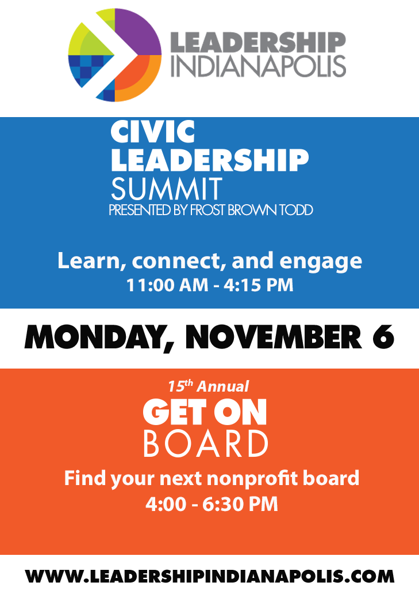
- NBI—Swap to Bank of Choice
- Aly Sterling—Swap to Inspire your board to lead
- Prosperity Indiana—Swap to capacity
- Spea
REAL ESTATE--None

FEATURES

CATEGORIES:
TAGS:

Sponsor’s insight
Boardable: https://www.boardableapp.com/blog/2017/building-a-better-board?utm_source=CharitableAdvisors&utm_medium=Email

CATEGORIES:
TAGS:

LOCAL NEWS

People on the move

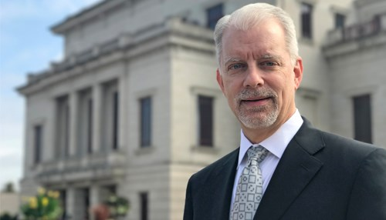The Center for the Performing Arts in Carmel has named Jeffrey McDermott president and chief executive officer. McDermott, who has served in the role on an interim basis since August 2016, will also lead the affiliated Great American Songbook Foundation.—Inside Indiana Business

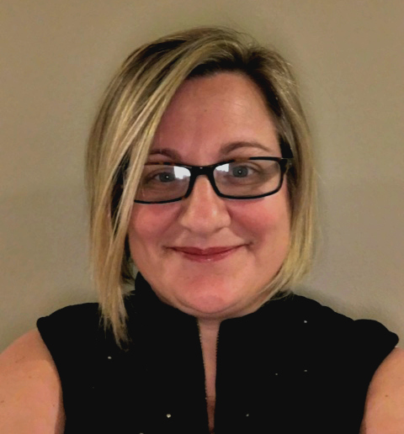Michelle Linden Mates to the Smart Steps program specialist position at Chaucie’s Place where she will focus on development of curricula and assessment. Jack P. Powel 317-759-8008; jack@chauciesplace.org

Jewish Federation of Greater Indianapolis has promoted Irina Brodskiy to campaign operations manager, responsible for day-to-day operations of the community campaign and database management. She has been at the Federation since 2009. https://s3.amazonaws.com/files.formstack.com/uploads/1959371/31243045/344488451/31243045_irina-brodskiy_headshot.jpg
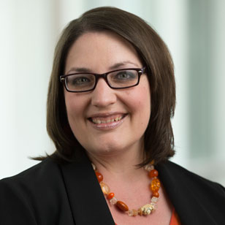Rachel Pease has joined Indiana Tech as vice president for institutional advancement. Pease previously served as senior advancement officer for Dickinson College in Carlisle, Pennsylvania.—Inside Indiana Business
Stand for Children Indiana has named David Patterson marketing & communications director. Patterson most recently served as central region communications manager at the American Federation of State, County and Municipal Employees International Union. –Inside Indiana Business
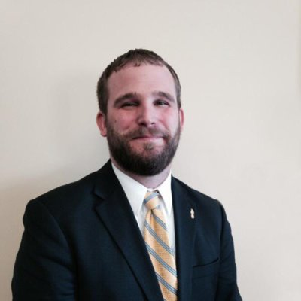Conner Prairie has named Richard Cooper as vice president-chief programs officer. Cooper joins the leadership team of the museum from the National Underground Railroad Freedom Center in Cincinnati, where he had worked since 2004. Duane Brodt brodt@connerprairie.org (800) 966-1836

Announcements

United Way of Central Indiana awarded $2,775,000 in grants to four local organizations as part of Great Families 2020, the initiative designed to transform the lives of Indianapolis' most vulnerable families in neighborhoods with the most need. https://uwci.org/great-families-2020/
The founder of Fort Wayne-based Sweetwater Sound has announced a big donation to music students in the state's largest school district. Chuck Surack and his wife, Lisa, presented a $500,000 check and an additional pledge of 100 band and orchestra instruments to Fort Wayne Community Schools. http://www.insideindianabusiness.com/story/36219076/chuck-and-lisa-surack-give-500k-to-student-musicians Feel free to strike. Lots of prof deve to fill the newsletter.
This year's Indiana State Fair attracted nearly 907,000 attendees. The figure represents a 24 percent increase over last year and is the sixth-highest attendance total in the event's history. http://www.insideindianabusiness.com/story/36179913/indiana-state-fair-draws-over-900k
Lutheran Child & Family Services broke ground on Trinity House. The 3,000- sq .ft. home will provide better programming, enhance the therapeutic environment, support better outcomes and maintain an appropriate level of support for our current contracts with Indiana Department of Child Services, Indianapolis Public Schools and Council on Accreditation.
https://www.facebook.com/events/1749966971963032/
Child Advocates Undoing Racism documentary will air on WTIU Public Television on September 3 at 2:30 p.m. and October 12 at 9:00 p.m. The documentary explores the disproportionality of African American children in the child welfare system and how one non-profit agency in Indianapolis is fighting to reverse that legacy for children of color. https://www.childadvocates.net/undoing-racism-community-call-action/
Startup Ladies, an Indianapolis-based company focused on connecting entrepreneurial women with resources and investors, is launching a new source of funding and two new programs http://www.insideindianabusiness.com/story/36232807/new-grants-programs-to-boost-women-entrepreneurs

Professional development
What not-for-profit leadership needs to know about technology and cybersecurity on September 13 from 7:30-10:00 a.m. at Butler University (4600 Sunset Avenue, Ford Salon at Robertson Hall .) Join Barnes Dennig Director and technology expert, Robert Ramsay, CPA, CISA (Certified Information Systems Auditor), CITP (Certified Information Technology Professional), as he leads an interactive discussion on what not-for-profit leaders need to know about technology and cybersecurity. Free. 1.5 hours of CPE credit available. To register: http://www.barnesdennig.com/event/not-for-profit-leadership-technology-cybersecurity
Big bet philanthropy on Sept. 13 from 11:30 a.m. at The Willows on Westfield (6729 Westfield Blvd.) Are prizes & competitions the future of philanthropy? Jaison Morgan, CEO of Common Pool, will share his experiences designing & managing successful prize and competition programs to find solutions for complex social issues. $30 members/ $60 nonmember. Cost: $30.00. To register: http://www.afpindiana.afpnet.org/Event/EventDetail.cfm?EventID=186082
Join the Grant Professionals Association for a Meet the Funders panel discussion of The sustainability question on September 19 at 8:00 a.m. at INHP (2620 Kessler Blvd., Suite 230.) $10 members/ $20 non members. https://www.grantprofessionals.org/ev_calendar_day.asp?date=9/19/2017&eventid=126
Leadership Indianapolis offers the Civic Leadership Summit, presented by Frost Brown Todd, on September 26 from 11:00 a.m.-4:30 p.m. at the Children’s Museum of Indianapolis. The Summit brings civic leaders together to learn more about pressing community issues, get involved in addressing them, and hone their community leadership skills. The Summit is a perfect opportunity for both emerging and experienced community leaders. Registration, pricing and additional details are available at http://www.leadershipindianapolis.com/Civic-Leadership-Summit.html
Capture compelling success stories group consulting on Sept. 27. Participants will also take home the requisite skills to draft a variety of success stories for your organization. $695. FMI: http://charitableadvisors.com/consulting/groupconsulting/capture-compelling-success-stories-nora-hiatt/
Create a donor engagement tool to launch your major gift effort group consulting starting on Sept. 29. Participants will create a visual presentation/engagement tool to foster communication with current and potential investors. This tool allows a new way to talk about (re-frame) concepts ranging from capital campaigns, to annual funds to planned gifts plus more. Series of three sessions. $695. FMI: http://charitableadvisors.com/consulting/groupconsulting/create-a-donor-engagement-tool-to-launch-your-major-gift-effort-t-j-mcgovern/
Growing strategically: How to manage new revenue streams and reporting requirements webinar on Sept. 30 at 1:00 p.m. Many nonprofits are looking to expand their funding sources out of necessity as their communities and missions are growing. Whether your organization is seeking new opportunities for grant funding or exploring new ways to earn revenue, it’s important you plan ahead for the burden of additional reporting and compliance requirements.
https://cc.readytalk.com/registration/#/?meeting=qe58o0g9mow8&campaign=evi88diw7vv2
The international youth protection symposium on October 17-18 at the Omni Hotel (40 W Jackson Place) will provide a vital opportunity for youth serving organizations to discuss the subject of child sexual abuse prevention, hear from leading experts in the field, and share ideas and best practices to collectively find more effective ways to address the issues. FMI and registration: https://iyps.kiwanis.org/

Volunteer opportunities

Bike MS is September 9 at Boone County 4-H Fairgrounds in Lebanon. We need individuals and groups for on site as well as for rest stops along the 25, 50, 80 and 100 mile routes. Shifts are available or join us for the whole day. www.bikeMSindiana.org

SWAP
NEED: Timmy Global Health is looking for projector that can be used for presentations in some of our communities. Please contact Zach Bowman at zach@timmyglobalhealth.org with any questions or how to donate.
DONATION: Vtech DS6151 expandable cordless phone system. Includes 1 main console and 4 handset. Contact Cynthia Morraz at cmorraz@communitysolutionsinc.net or 317-423-1770
TRENDS/RESOURCES

National news/4 items, includes artwork with each

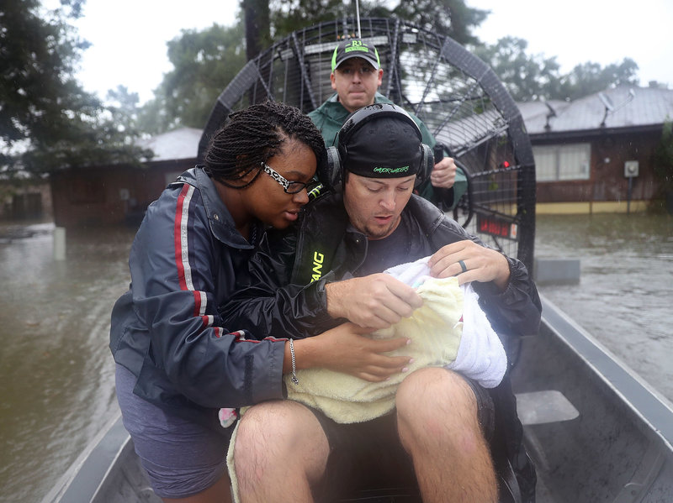Nonprofits, corporations help with Harvey disaster relief.
The American Red Cross, The Salvation Army, United Way of Greater Houston other nonprofits and businesses are raising funds and providing help for Gulf Coast communities affected by Hurricane Harvey.
http://www.npr.org/2017/08/28/546740254/corporations-pledge-millions-toward-relief-efforts-for-tropical-storm-harvey
How to succeed on a nonprofit board
A lot of businesspeople who join nonprofit boards enter their role with two very wrong preconceptions.
https://ssir.org/articles/entry/how_to_succeed_on_a_nonprofit_board
Understanding the mindset of Millennials
In the workplace, millennials are known for certain characteristics, such as being comfortable with uncertainty and technology, and having a hardwired sense of inclusion.
http://tinyurl.com/y9hd7ngq

Reduced performance triggers turnover for nonprofit executives.
Nonprofit organizations that have declining expenditures – an indication of reduced operations – are more likely to seek new leadership, according to a new study. https://news.ncsu.edu/2017/08/nonprofit-executive-turnover-2017/

SPONSORS’ INSIGHTS
Indiana University Lilly Family School of Philanthropy Historian Joan Johnson to speak on how women philanthropists helped women get the right to vote on Oct. 3 from 4:30-6:00 pm at the Indianapolis Urban League (777 Indiana Avenue). A panel of three Indianapolis women leaders will discuss how women today can leverage their voices, giving and volunteering to make a difference. Free. To RSVP: https://philanthropy.iupui.edu/news-events/event/following-the-money:-how-women-philanthropists-helped-women-get-the-right-to-vote.html?id=228

